



**Access to HE Diploma**

**Extended Project Guide – Report based on secondary research**

**What is the Extended Project?**

The Extended Project requires you to undertake an investigation into a topic of your choice. If you’re reading this guide, your final outcome will be a report of 2500-3000 words. This report will be based on your secondary research. You may decide to undertake some statistical analysis of existing datasets but you will not be undertaking any primary research yourself. You’ll be provided with an assignment brief outlining the steps that you need to take towards producing your report and how it will be graded. This guide is intended to provide further guidance and it is not written to guide you to write the report for a specific subject.

You will be assigned a project supervisor who will help you to select a suitable topic and will support you as you produce the project. They’ll also help you to identify any subject-specific conventions that you need to follow when writing your report.

**Your aims**

* To select a topic which is of interest to you and suitable for academic treatment with supervision from a subject-specialist tutor
* To formulate analytical/evaluative questions appropriate to the subject specialism which can be reasonably answered within the time and word-length constraints
* To research the subject in depth, placing it firmly within a subject-specialist perspective and using conventions appropriate to the subject discipline, including competent use of specialist terminology
* To interpret information and ideas and look at different perspectives and approaches
* To evaluate the significance of resources found, their validity and reliability, and to use your material to solve the questions set
* To use academic citation to support or illustrate your argument, using factual or theoretical understanding to address the questions you have set

**Your topic**

You may wish to think about:

* a subject of special interest to you outside the course;
* a subject related to a course area of special interest;
* a subject that will form part of a course you might take;
* a subject relating to an area of work that interests you.

For the Extended Project, you are not permitted to reuse work that you have already submitted for another graded unit. You can investigate the topic area further if it has interested you but you can also investigate a topic that you have not studied on the course.

You need to check with your tutor that the topic is in an area they can supervise. They may give you guidance beforehand about the areas that they are willing to supervise.

**Your project proposal form**

Once you have settled on a general area for your topic, you need to fill out a project proposal form. You’ll discuss your project proposal form with your project supervisor and they’ll be able to give you some pointers about where to go next.

We’ll go through each of the sections but you don’t have to complete them in this order. You might find it easier to formulate your title once you have considered your objectives and identified some sources.

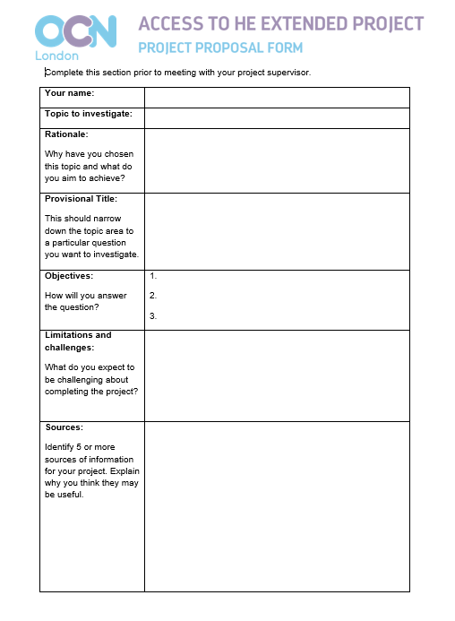**Rationale**

This will help you to really think about your project and why you want to do it. It will also help your project supervisor to understand where you want to go with your project and help to steer you in the right direction.

**Provisional title**

Your title should not just be your topic area. To meet AC3.1, you must: ‘Sustain a logical argument in an extended piece of work in form/s and using terminology consistent with subject specific conventions’. To sustain an argument you need to devise a title that is ‘arguable’! That is, it allows you to argue or investigate a certain position or perspective on the topic.

Such titles will normally consist of a question or a thesis statement.

If you’re not sure what is ‘arguable’ about your topic, then start doing some reading! Look at different authors and institutions approach to the topic, how they interpret it, what they think is important and how they differ from each other, or look at different theories you have studied and think about how it might apply to another area of life.

Make sure your project title isn’t too broad. Think about how you can narrow it down so that it applies to a specific area. You might find the topic more interesting if you apply it to something that you are passionate about (e.g. training to be a teacher) or something you have a personal connection to such as your family (e.g. treatments for people with dementia) or where you live (e.g. crime in Hounslow).

If you want to do some statistical analysis, make sure that there is a dataset available that you can use. Your supervisor may have some ideas and there are some suggestions about where to find data in the appendix to this guide.

For example:

*Why is donepezil widely used as a treatment for Alzheimer’s Disease?*

In this project, you would look at medical, economic and sociological explanations for the use of the medication donepezil in treating Alzheimer’s Disease with a particular focus on why donepezil might be used instead of or alongside other treatments (e.g. medical benefits and precautions, cost, social conditioning that medication is taken to treat disease). You would structure your report into sections for each of these explanations, coming to a conclusion about whether donepezil is an effective treatment and how each of the explanations helped you to reach this conclusion.

*To what extent, How far…?* and *How significant…?* are similar question types you could use.

*Does a good Ofsted report improve a school’s GCSE results?*

In this report, you could combine data about Ofsted report results and schools’ GCSE results (e.g. % of learners getting Grade 5 or above in English and Maths GCSEs), looking at results before an Ofsted inspection and afterwards to see if there is an improvement. This would require you to do some statistical analysis to put together a dataset from different sources (e.g. government school performance tables: https://www.gov.uk/school-performance-tables). This is a broad title, so in your objectives, you want to narrow it down – for example, you might want to focus on your local area so that you don’t have too much data to put together. You would then undertake an analysis of your results using information from your further reading, coming to a conclusion and making recommendations for further investigation into the topic.

*“No direct correlation between certain crimes and police numbers” (Theresa May, March 2019)*

This title uses a quote where the speaker is taking a position on a controversial or debatable subject. There are several ways that you can approach this quote and you would want to add a subtitle to signpost which approach you are taking (for example, *police numbers and car theft in Hounslow, 2010-2020; a comparison of police funding and crime incidences in London and Manchester)*. If you are working with a report format, you may want to undertake some statistical analysis using crime data to see if there is a link between police numbers and a particular type of crime or incidences of crime in a certain area. In your discussion, you might consider how this statistical analysis might inform government or police force decision making.

**Objectives**

Your objectives will help you think about how you are going to answer the question and the approach that you are going to take. The objectives should show what you want to achieve by the end of your project. Specifically, what question do you want to answer?

You might find it useful to create a mindmap or list of the different approaches to your question and topic area. You can then narrow it down to a few objectives that you think you can cover in your research and report. Your objectives may relate to what you want to find out or a new skill you want to learn (e.g. statistical analysis techniques).

**Limitations and challenges**

You should try to be specific about what you think the limitations and challenges of the project will be so that your project supervisor can help you to consider how to address them. You will find your project supervisor’s advice more useful if you have already done some reading and thinking around the topic before you submit your project proposal form.

Some limitations and challenges may be:

* The topic seems too broad (or narrow) to cover in a 3000 word report and the time given to complete it
* There are too many sources
* There are not enough sources
* You’re struggling to find sources that are academic or reliable
* You can’t access the sources that you think you need
* You don’t understand what you are reading
* You haven’t studied the subject before and don’t understand some of the conventions
* You need to develop your skills so you can understand or analyse the information (e.g. reading graphs, interpreting data)
* You are not very good at time management
* There are other demands on your time that make research difficult
* You’re not sure how to plan a 3000 word report
* You have a disability that might make undertaking the project more challenging than for other students (learning or physical)
* You have limited access to a computer

**Sources**

In this section, you may identify specific sources that you think will be useful (e.g. a particular book or article) or a specific category of sources, such as a set of statistics, guidelines, policy documents, primary sources. Try to be precise e.g. ‘Crime Survey for England and Wales’ rather than ‘statistics on crime’.

Make sure that you can access these sources explain why you think they might be useful. This will help your project supervisor to see if you’re on the right track with finding suitable sources or if you need some more pointers.

If the topic is new to you then start with a basic text – such as the ‘Very Short Introduction’ series by Oxford University Press (often written by academics working in the field and include references and further reading) or ‘Introducing…’ series by Icon books (overviews using simple text and cartoons).

The Virtual Training Suite website - <http://www.vtstutorials.co.uk/> provides information about how to do internet research in different subject areas. It’s a little old (last updated in 2011) but should give an overview of the types of sources available online for your subject area.

Appendix 1 in this guide also provides some guidance about where you might be able to access information for your project. Wherever you find your sources, make sure that you evaluate the information to consider whether it is useful:

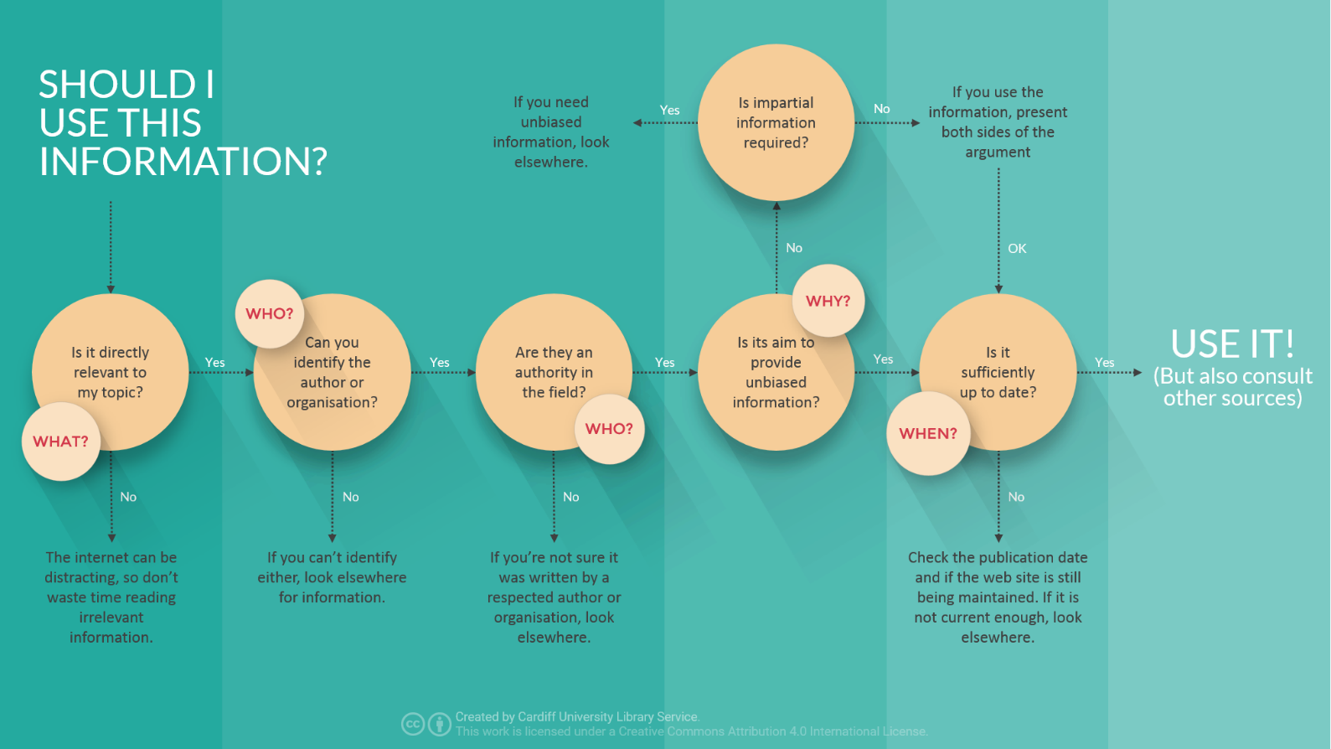

A larger version of this chart is available at: <https://ilrb.cf.ac.uk/evalinfo/images/evaluation_flowchart.png>

As you start to research, begin your bibliography. A bibliography is a list of all the sources you consulted in your research, not just the ones you actually quote or refer to in your report. You could start a document called Bibliography and enter into it all the text you are reading in the correct bibliographical format. Enter each new source in the appropriate place alphabetically as you begin to look at it. This way you will have your bibliography complete at the end – you won’t have to compile it separately.

Unless otherwise instructed, you’ll be expected to reference your work using Harvard referencing - <http://www.citethisforme.com/harvard-referencing>

MS Word has useful tools to help with referencing when you are writing up your project - <https://support.office.com/en-ie/article/create-a-bibliography-citations-and-references-17686589-4824-4940-9c69-342c289fa2a5>

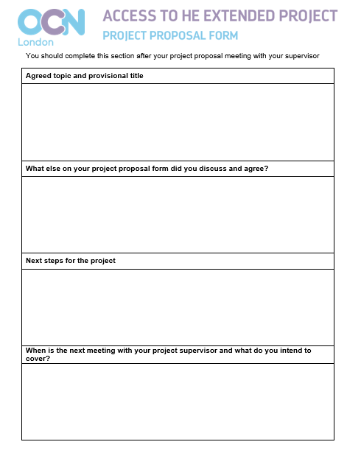**Meeting with your tutor**

You’ll meet with your tutor to discuss your project proposal. During the meeting, you’ll complete page 2 of the project proposal form to record what was agreed at the meeting and your next steps. You may start to put together your action plan at this meeting or arrange for you to have this ready for the next meeting.

You’ll meet with your tutor several times during the project process so that they can monitor your progress and offer advice. Your tutor will keep a log of what was discussed and the support that they give you. This tutor log will help to provide the evidence for the grade you are given for GD6: Autonomy and/or independence.

Meetings with your project supervisor align with the steps of producing the Extended Project. These will be available to all learners and you will not demonstrate autonomy and independence by failing to attend them. You can ask for extra meetings or support if you have a problem.

To demonstrate that you are an autonomous and independent learner you should:

* **Prepare the required materials for the meeting.** You should bring your action plan to each meeting and material relevant to the step you are discussing (e.g. project proposal plan, report plan, draft report).
* **Update your action plan with your progress.** If you are not on track, you should have adjusted your action plan accordingly. You should be able to demonstrate that you have thought through the consequences of not keeping to your action plan.
* **Think about any problems or challenges you are facing.** You can ask your project supervisor for their advice but you will show that you are an independent learner if you have already looked into different solutions. ‘Should I do x?’ is a better question to ask than ‘What should I do?’.
* **Respond to your tutor’s advice.** If you haven’t taken your tutor’s advice from a previous session, be able to give good, well thought-out reasons why you are not following it. It is better if you can show that you tried their advice and decided it wouldn’t work rather than ignored it completely.
* **Be honest.** This unit is helping you to prepare for higher education so it will be more useful to you to discuss with your project supervisor how you are finding the process rather than try to cover up if you’re finding it stressful, bewildering or dull. They may be able to give you good advice about how to manage your time better or reorient the project so you find it more interesting.

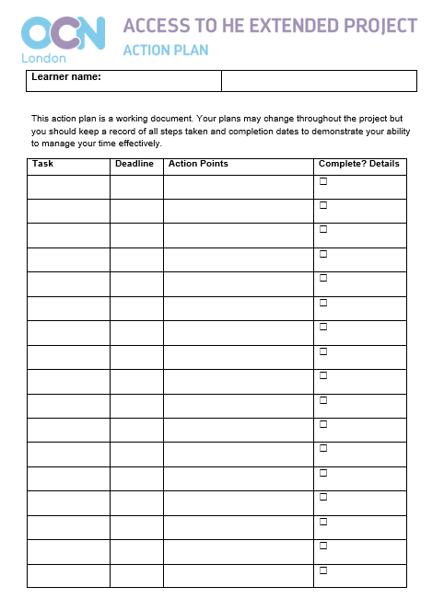**Action plan**

Your action plan is a working document. Start by breaking each of the steps of your project down into tasks and assigning deadlines. As you complete each of the tasks, tick them off as complete and add action points – things that you will need to do for the next task or later in the project. Provide some reflection about how you think the task went. You may want to add extra tasks or adjust later deadlines based on your action points.

If you’re recording your action plan in a word document and make adjustments, it is better to add these adjustments with the date rather than deleting the original plan. This will provide better evidence of the process that you went through to produce the project. Tasks may not go to plan, but it’s the evidence of how you respond to things going wrong that matters, not getting it right first time.

**Research log**

You should produce your research log alongside your bibliography as you go along. It’s recommended that you annotate the entry for each of your main sources with short notes about what the source covers, whether you will use it in the report and anything you need to bear in mind about the reliability or validity of the source.

The notes do not have to be extensive – make sure that they contain information that will be useful to you. You don’t have to comment on every source you have consulted (though you may find this useful), just the ones that you think will be relevant to your final report.

For example:

Science Learning Hub. (2010). The body’s first line of defence. [online] Available at: https://www.sciencelearn.org.nz/resources/177-the-body-s-first-line-of-defence [Accessed 18 Apr. 2019].

*Basic overview of how first line defences prevent entry to body. No author but website produced by New Zealand government and videos are explained by doctors/professors.*

Masani, Z. (2019). Amritsar: Reviewing a Massacre. *History Today*, [online] 69 (4). Available at: https://www.historytoday.com/reviews/amritsar-reviewing-massacre [Accessed 18 Apr. 2019].

*Review of Kim Wagner’s ‘Amritsar 1919’ and Anita Anand’s ‘The Patient Assassin’. Useful summary of key points from Wagner’s book – section on whether massacre was pre-meditated. Looks like Wagner’s book may be worth reading. Also listen to Masani’s programme on Radio 4.*

Dickens, C. 2008. *David Copperfield.* Oxford: Oxford University Press.

*Main text so very useful! Introduction by Andrew Sanders – focus on parallels and differences between Dickens’ life and David Copperfield, though goes off on other tangents – a bit difficult to follow. May be useful for introduction to report. Use further reading section at end of book - though there may be more recent articles as this version from 2008.*

**Report plan**

It is important that you plan your report before you start to write it. You will need to show your report plan to your tutor as part of Step 3 of the Extended Project process.

There is no set layout for your report plan, so you are welcome to use whichever approach you find useful (e.g. mind map, outline plan, paragraph plan). Reports normally follow a logical structure with sections. Your project supervisor may advise you to follow the conventions for a particular type of report – the conventions for a business report are below. Alternatively, they may advise a different format. You report plan should make clear what you intend to cover in each section, including any quotes or references you may use, so they can make sure you are on track with the format.

The following resources will give you more guidance about how to plan and write your report:

Cottrell, S. (2013). *The study skills handbook.* 4th ed. Basingstoke [England]: Palgrave Macmillan.

Learnhigher. (2012). *Structure of reports.* [online] Available at: <http://www.learnhigher.ac.uk/writing-for-university/report-writing/structure-of-reports/>

Solent Online Learning. *Report writing summary leaflet.* [online] Available at: <https://learn.solent.ac.uk/pluginfile.php/283311/mod_book/chapter/36550/succeed%40report%20writing%20summary%20leaflet.pdf>

University of Kent. *Report Writing – Quick Guide.* [online] Available at: <https://www.kent.ac.uk/learning/resources/studyguides/reportwritingquickguide.pdf>

**Business report structure**

A formal business report normally includes the following sections:

**Title:** A short and unambiguous statement, stating exactly what the report is about. (5 – 15 words)

**Executive Summary:** A summary that helps the reader quickly grasp the report’s purpose, conclusions and key recommendations (100 words)

**Introduction / Terms of Reference:** A brief description of the context, the issue or problem to be reported on, the specific questions the report answers, the limitations of the report and any assumptions made. (200 words)

**Methodology:** Methods of data collection, sources of primary data (you are not doing the primary data collection yourself, but the data source may indicate how it was collected), secondary sources used, reasons for selecting the methodology.

**Results /Findings:** The findings presented in a clear and simple format. Data should be organized in tables, graphs and/or charts where possible. Include an explanation of any statistical analysis.

**Discussion:** The discussion should give enough information, analysis, and evidence to support your conclusions and provide justification for your recommendations. It should follow a logical and systematic organisation. Where the report’s purpose is to recommend the best solution to a problem, you should show clear analysis of all the options. You should explain any analytical framework you used, such as SWOT or cost benefit analysis.

**Conclusion:** A summary and interpretation of the findings; explaining what the results mean. Relate the conclusions to the original report issue/problem. Limit the conclusions to the data presented; do not introduce new material. (200 words)

**Recommendations:** Specific suggestions for actions to solve the report problem. Present each suggestion separately and begin with a verb. Number the recommendations and arrange them in order of importance. Describe how the recommendations would be implemented (if this was in the terms of reference). (200 words)

**References:** A list of sources cited in the text of the report (listed in alphabetical order by surname of the author).

**Appendices:** Additional information related to the report but not essential to the main findings, e.g. glossary of terms, statistical data tables. Appendices are numbered, for referencing in the text.

If you’re writing a business report, then this resource may also be helpful:

University of Melbourne. *Business Reports - Giblin Eunson Library Helpsheet.* [online] Available at: <https://library.unimelb.edu.au/__data/assets/pdf_file/0005/1924160/Business_Reports.pdf>

**Writing your report**

Once you have discussed your report plan with your project supervisor, it will be time to start writing your report.

You need to make sure that your report follows the structure you have agreed with your supervisor. If you’re not sure where something should go then make sure you discuss this with your supervisor.

Your report should be written in an academic tone. The Academic Phrasebank from the University of Manchester is a good resource for academic language that can be used in reports: <http://www.phrasebank.manchester.ac.uk/>

You’ll submit a draft version of your report to your project supervisor for review. This doesn’t have to be your first report - it’s advised that you proofread your report to make sure that:

* you’ve addressed your report title
* the content of each of your sections conforms to what is expected by the section title
* information that you have used from your sources is referenced
* you can follow the in-text citations through to the bibliography (for example, the name in the citation appears in the reference in the bibliography)
* sentences flow and have a formal tone
* images, diagrams or graphs are clearly labelled and numbered. If these have not been produced by you then they should reference the source.
* you’ve corrected any typos (don’t rely on spell checker as it may not catch mistypes such as ‘this’ and ‘thus’ or ‘car’ and ‘care’).
* your report is within the word limit and the sections are well-balanced

Your project supervisor will give you some feedback on your draft and may make some limited annotations. You should adjust your report as you feel is appropriate.

**Submitting your project**

Congratulations, you’ve finished! As this is a project rather than just a report, remember that you need to submit evidence from each of the steps with your final report. This will help the assessor to see how your project has developed.

Clearly label all work you submit and present it in a logical order (e.g. following the order of the steps).

**Appendix 1: Where to access information**

This list is not exhaustive but should help you to access better quality sources than you can just find with an internet search!

**College library/learning resource centre** – hopefully you’ve already been using this! The library staff may be able to advise you about their collection and where you might be able to find the information you are looking for within the college library or elsewhere.

**Local library** – free to join and may give you access to a wider range of materials than your college’s learning resource centre. Membership of your local library will also often give you access to inter-library loans (getting material from other libraries within the local area or throughout the UK) and online services, such as an e-library, newspaper archives (you may need to be on a library computer to access this) and free access to reference materials like Oxford Reference Online.

Find your local library service: <https://www.gov.uk/local-library-services>.

**University library** – contact your local university to find out if you can get a reader’s pass. Before you go, check their website to see whether there are any restrictions on who can get a reader’s pass and search their catalogue online to see if they have the sources that you want to use. Universities are more likely to let you use their library if you have a list of books or resources that you want to access there.

**Legal deposit libraries** – these libraries are entitled to receive a free copy of every item published or distributed in Britain so have more extensive collections. You can apply for a reader’s pass:

* The British Library, London and Boston Spa – register for an account online and order materials before you visit as it can take up to 48 hours for items to be available - <https://www.bl.uk/help/how-to-get-a-reader-pass>
* Bodleian Libraries, Oxford - <https://www.bodleian.ox.ac.uk/using/getting-a-reader-card>
* Cambridge University Library - <http://www.lib.cam.ac.uk/using-library/joining-library>
* National Library of Scotland, Edinburgh - <https://www.nls.uk/using-the-library/library-cards>
* National Library of Wales, Aberystwyth - <https://www.library.wales/visit/before-your-visit/readersticket/>

**E-books** – your college or local library may have access to e-books. These can also be bought online or certain chapters previewed (e.g. Amazon’s ‘Look Inside’ function). If you are looking at a book online, make sure you are accessing it legally.

Books that are out of copyright can be found on Project Gutenberg - <http://www.gutenberg.org/>

Extracts and full books can be found on Google Books - <https://books.google.co.uk/>

**Specialist libraries** - there are a range of libraries with a specialist focus that you may be able to access (e.g. BFI Reuben Library for film, National Poetry Library at the Southbank Centre). Your project supervisor will be able to point you in the right direction.

**Workplace libraries** – you may have access to books and journals through your workplace (or someone that you know). For example, if you work for the NHS then you should be able to access a health library at your NHS trust or hospital (<https://www.hlisd.org/>) and you may be eligible to access journals online via NICE (<https://www.nice.org.uk/about/what-we-do/evidence-services/journals-and-databases>).

**Online journals** – some journals or editions of journals are available online for free. You can search for articles using websites like Google Scholar (<https://scholar.google.com/>) or PubMed for life sciences (<https://www.ncbi.nlm.nih.gov/pubmed/>). Your college may subscribe to an e-journal site like JSTOR - <https://www.jstor.org/> or SAGE - <https://journals.sagepub.com/>. You may be able to get online access to a journal by going to a university library or the British Library.

If you can’t access an article, you can sometimes access where that article has been cited (e.g. using Google Scholar) and use another article to understand the key points from the original article. If you have not used the original article, then you need to cite it as a secondary reference (<https://ait.libguides.com/c.php?g=280082&p=1866386#Secondary>).

**Online databases** – there may be a database of material relevant to your topic online that is searchable. These may be produced by an official body such as NICE or Office of National Statistics. Sometimes, the material will also be interpreted such as statistical bulletins that the Office of National Statistics produce.

Universities often produce databases as part of a funded project – normally, this will be a good source of information but make sure you investigate how the database was produced (e.g. read the ‘About’ section) as some sites with a university web address may just be a single university student’s project and not produced with the same academic rigour and peer-review as a funded project.

**Podcasts** - podcasts can be particularly useful for helping you to identify the key debates and themes in your subject area. You will want to follow up what you hear on podcasts with written sources.

Search podcast sites (such as Apple iTunes) for podcasts in your subject area. Podcasts by institutions recognised in the field (e.g. journals, organisations) or involving academics are likely to give more reliable information. Some universities record lectures and make them available online as a podcast (e.g. Oxford (<https://podcasts.ox.ac.uk/>), Liverpool (<https://www.online.liverpool.ac.uk/connect-with-us/podcasts>), Birmingham (<https://www.birmingham.ac.uk/news/podcasts/index.aspx>).

BBC Radio 4 podcasts can be a good starting point: <https://www.bbc.co.uk/podcasts>

For example: In Our Time - academics talk about a topic. Broad range of topics in archive, including history, literature, psychology, science, philosophy, sociology, religion etc. Often have an introductory reading list on the topic.

Inside Science – discussion about scientific research and controversies

Click – technological news and issues

From Our Own Correspondent – stories and analysis from BBC foreign correspondents, often includes stories not covered in the news

Beyond Today – current affairs

All in the Mind – for psychological studies

Thinking Allowed – for sociological studies

**Newspapers and online news sites** – newspaper articles, particularly, opinion pieces, can be a good source of information about different views on a controversial subject. However, care needs to be taken when using news sites to ensure that you have considered the bias and angle of the piece. Articles normally do not include citations or references (although online sites may contain links to other sources of information) so it can sometimes be difficult to corroborate whether the information is correct or not – if you’re going to cite a fact from a newspaper article, make sure you confirm it by checking elsewhere.

**Videos and documentaries** – Youtube and similar sites allow people to share their own videos and old documentaries. As with newspaper articles, these can be useful to understand different people’s opinions or perspectives, or to watch primary sources such as speeches and films of events. If you are watching a documentary on Youtube (particularly one produced just for the site), these are not normally referenced so you need to check any facts and be wary of bias.

Documentaries can also be watched on catch-up services like BBC iPlayer or subscription services like Netflix and Amazon Prime. There are also some subject specific subscription services (e.g. History Hit TV). You may be able to find a newspaper review of a TV documentary, which may give you an insight into the quality of the programme and research.

**Museums, galleries, historic sites and exhibitions** – visiting a relevant museum, gallery or historic site can be a useful way to broaden your knowledge of the sources available and to consider an interpretation of the subject. Many museums also have a library or research room where you may be able to access books and materials relevant to their collection. If you’re not able to visit an exhibition (or it was in the past) then the exhibition catalogue can give a good insight into what was displayed - these are normally more scholarly and referenced than the labelling in the exhibition. You may need to contact the site beforehand to check that you will be allowed to use the research room.

**Where to find statistical data**

Data published by the UK government - <https://www.gov.uk/government/statistical-data-sets>

Office for National Statistics - <https://www.ons.gov.uk/>

UK Data Service - <https://www.ukdataservice.ac.uk/> - social, economic and population data

World Health Organisation – <https://www.who.int/healthinfo/statistics/en/> - world health data and statistics

London datastore - <https://data.london.gov.uk/> . Data relating to London. Other city and county councils will also have local data on their website, if you search by council name and data.

World Bank Open Data - <https://data.worldbank.org/> - global development data

Crime and policing data - <https://data.police.uk/>

Charities may provide statistics and data sets relevant to their mission, for example, Cancer Research UK cancer statistics - <https://www.cancerresearchuk.org/health-professional/data-and-statistics>

**Appendix 2: Resources to help you to develop your statistical analysis skills**

University of York. *Spreadsheets & databases.* [online] Available at: <https://subjectguides.york.ac.uk/skills/spreadsheets>

BBC Skillwise. *Graphs.* [online] Available at: <http://www.bbc.co.uk/skillswise/topic-group/graphs> - basic guides and exercises on graphs and averages

Skills you need. *Simple statistical analysis.* [online] Available at: <https://www.skillsyouneed.com/num/simple-statistical-analysis.html>

Cottrell, S. (2013). *The study skills handbook.* 4th ed. Basingstoke [England]: Palgrave Macmillan – chapter on confidence with numbers

Khan Academy. *Statistics and Probability.* [online] Available at: <https://www.khanacademy.org/math/statistics-probability> - videos and activities